SJN1 (Nyland Ranch) was installed 1968 and repaired several times due to damage sustained by farm activities. It was abandoned 1985 due to difficulties maintaining a continuous record during annual flooding (extract from Schultz 1978 below). A digital caliper system was operated briefly for a few years after the 1989 Loma Prieta earthquake. The creepmeter was reinstalled in 2004 and operated until 2010.

Latitude 36° 51.3' Longitude 121° 32.7 Position 307.7 km 12-meter rods, 0=45°

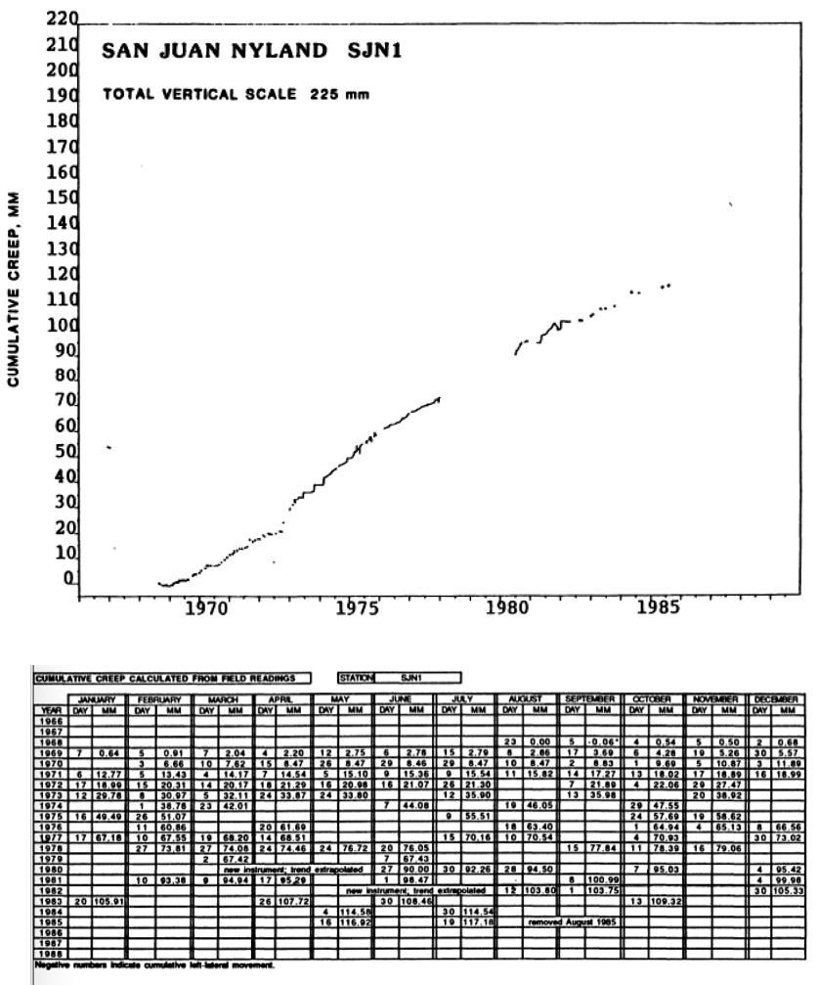The San Juan Bautista (Nyland Ranch) creepmeters were installed during August, 1968, on the San Andreas fault at a site 1.4 km northwest of Mission San Juan Bautista. The installation consisted of a pair of crossed rods buried in alluvium a few centimeters below a nearly flat surface. Creep activity at this site was composed of occasional minor events of up to 1 mm in amplitude, superimposed on a background of nearly steady-state long-term slip of about 8 mm/yr, with a distinct seasonal variation. SJN1 was destroyed in early 1980 during excavation of a broken water pipe, and a replacement instrument was installed in June, 1980. Measurements from a nearby alinement array were used to establish a starting point for the data from the new instrument. This instrument in turn was destroyed in summer. 1982, during installation of a natural gas line to the landowner's house. A replacement instrument was installed in August, 1982, but high ground water made operation of the instrument extremely difficult. The site was abandoned in August, 1985.



An invar rod and large range LVDT was installed in 2004. The data show a large seasonal term of 7-9 mm (clay expansion) superimposed on a long term creep rate of 8.8 mm/yr.

Behr, J., R. Bilham, P. Bodin, R.O. Burford and R. Burgmann, Aseismic slip on the San Andreas fault south of Loma Prieta, *Geophys. Res. Lett.,* 17, 1445-1448, 1990.

Linde, A. T. M T Gladwin, M J S Johnston, R L Gwyther and R G Bilham, A slow earthquake sequence on the San Andreas fault, *Nature(Lond).*, **383**, 65-68. 1996.

Schultz, S. A catalog of creepmeter measurements in California from 1966 to 1988 Open File Report 89-650 pp. 196