**Gozene**: 38.1759°N, 38.0103°E, length 5 m, obliquity 30°, installed 14 March 2023

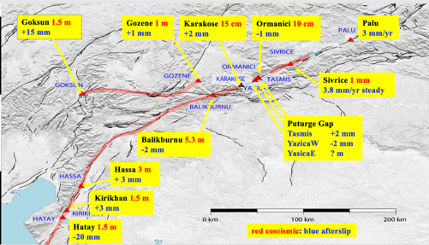

Map showing site locations

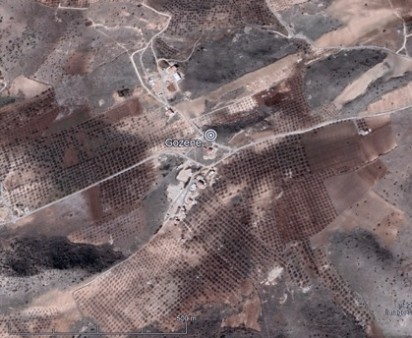

Figure 11. The Gozene creepmeter was installed across a new rupture in the village of that name. The instrument adjoins the road a few meters to the south of a ruptured water tank with about 80 cm of offset in surface soils containing numerous rocks. D-cell batteries power the system.

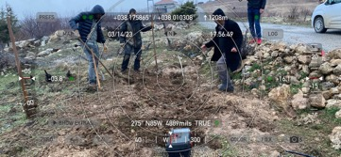 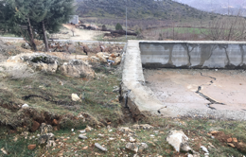

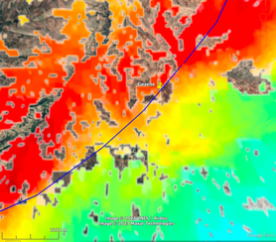The data from Gozene show a fairly steady rate of afterslip of 3.8 mm/year (Figure 2) with curious reversals at intervals of several weeks. We suspect these reversals may result from slip on subparallel fissures.

