**Hatay**: 38.3870°N, 36.2803°E, length 26 m, obliquity 30°, 5 March-16 July 2023

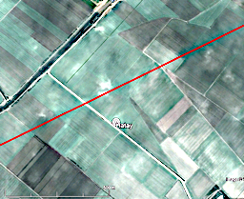

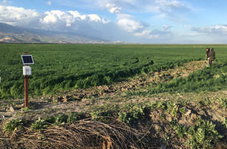

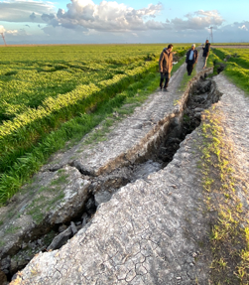

Figure 1. The 26 m long Hatay creepmeter was installed 6 March next to a road with multiple fissures crossing a former lake bed a few km north of the Hatay airport and is the southernmost of the sites we instrumented. We spanned about five (≈4-cm-wide) fissures near a road repair with apparent sinistral offset of about 1 m. In the 6 months following installation the creepmeter recorded 20 mm of contraction. It is probable that the main rupture passes to the northwest of the creepmeter location. A nearby methane seep detonated during the mainshock and, according to villagers, burned for about 5 hours. The region of this methane vent subsided in a minor graben that at the time of the visit had been flooded to a depth of more than 1.5 m.



Figure 2 First three weeks of data from Hatay shows 0.18 mm/day of linear contraction across co-seismically-opened fissures in former lake sediments. Contraction eventually exceeded 25 mm is believed to arise from gravitational closing of open fissures.



Figure 3 Data recorded between March and July across fissures in the Hatay lake bed show cumulative contraction exceeding 25 mm. We attribute this to the closure of open fissures, at rates of up to 0.6 mm/hour. The instrument was removed in June.