**Karakose 38.0697°N, 38.4983°E**

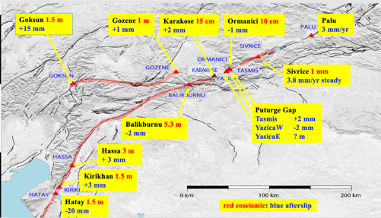

Map showing site locations

Two instruments were installed across what is interpreted to be a hillside *Sackungen*, afault that develops as a result of hillside de-butressing, here possibly caused by its location within a 1.25 km wide releasing bend in the East Anatolian Fault. The feature is manifest as a 10-m-wide shallow graben, bounded by two faults on SE sloping hillside. The upper bpounding fault was followed 200m to the SW. A 6-m-long instrument crosses the uphill fissure obliquely at 30°. This fault slipped ≈30 cm in the earthquake. A 12.5 m instrument crosses both the faults at 90° but this instrument is only half-buried in the graben soils, the remainder being covered with rocks, and therefore exposed to surface temperatures.

*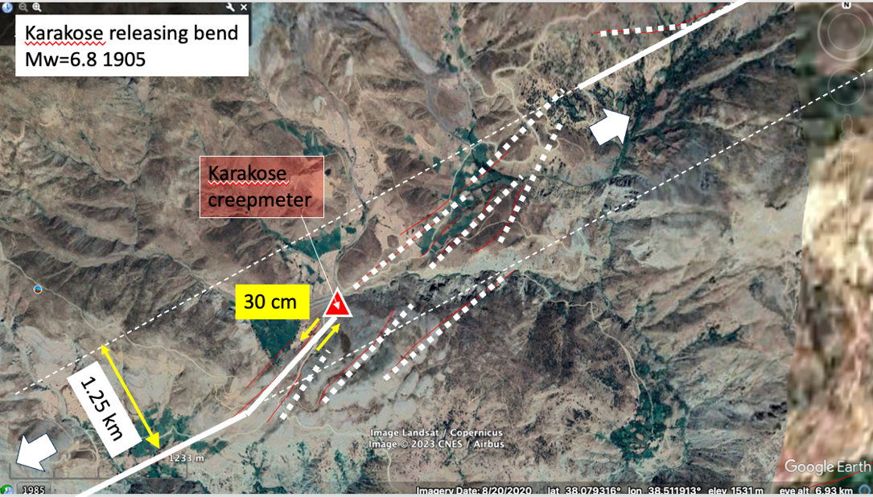Fig.1 Location of the Karakose instruments. Coseismic slip in the first of the Kharamanmaras ruptures terminated here with 30 cm of slip up to, but not more than 30 m NE of the instrument. A Mw6.8 earthquake occurred near here in 1905.*

*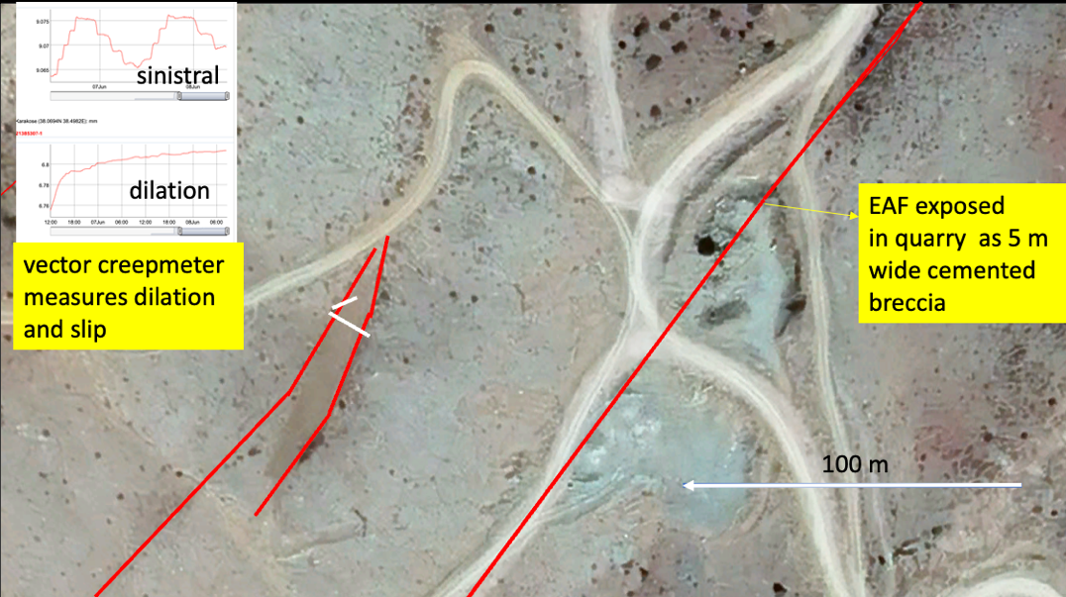Figure 2 Close-up of hillside sloping to the SE showing the two creepmeters (white bars) crossing two graben-bounding faults (red). The width of the graben is about 11 m where the two instruments are installed and the darker area between them represents soil development. The East Anatolian fault is exposed ~100 m to the east in a quarry that shows a rich spectrum of fault features, but which does not appear to have slipped coseismically in 2023.*

*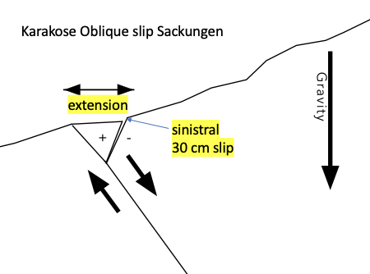Figure 3 Cross section viewing SW showing inferred surface faulting dipping into the hillside.*

The instruments were installed with cell telemetry starting in June 2023, which in November 2023 (after cell access was denied) was replaced by a local recording system powered by D-cells. In July 2024 power was changed to a solar powered 1.3AH lead acid battery. A mulfunction occurred 2 September 2024 that resulted in unreliable data that are omitted from Figure 4.



*Figure 4 A year of data from the Karakose Sackungen.*

**Interpretation**

Both instruments record contraction during the year of measurement, but neither instrument tracks the 20°C annual temperature cycle as would be anticipated were the signal an instrumental response to temperature. Sudden temperature drops recorded by the subsurface temperature sensor occurs during heavy rain, or during snow melt, and this is responsible for the two minor signals in August and September 2023. A maximum contraction signal accompanies the first winter snowfall, which we consider evidence for shallow fault consolidation associated with water infltration into the fault. Contraction and expansion cycles during snow cover may represent meltwater events rapidly cooling the carbon rod, which slowly recovers in temperature in the following several days.

The half millimeter of dextral slip recorded by the oblique instrument, in the opposite direction to the ≈30 cm sinistral coseismic signal, suggests that no afterslip has occurred at this location. The 2.5 mm of rapid graben contraction, occurring in Nov 2023 during inferred heavy rain/snow is also opposite in sign to the signal that created the Sackungen. In summary, the Karakose location shows no evidence for continued afterslip. We continue to record the signal here in that a local earthquake may induce further subsidence of the graben.