**Kirikhan** 36.4791°N, 36.3339°E, 5 m length. Installed 4 March 2023

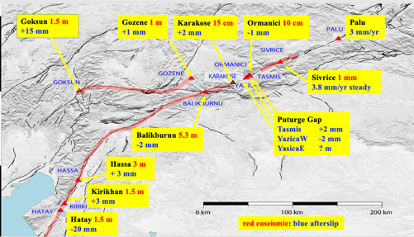

Map showing site locations

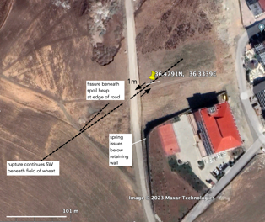 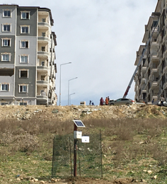

Figure 61. Kirikhan creepmeter installed 4 March on west facing slope near edge of road that had been offset ≈1 m during mainshock. A fence was placed around the transmitter box to keep stray dogs and sheep from the cabling.

The site was selected because slip here (1-1.5 m) was considerably less than that observed a few km to the north (3 m). The creepmeter recorded less than 1 mm of dextral slip in the first month (3.6 mm/yr) with two reversals, the second of which we attribute to rain. Current dextral rates are ≈0.1 mm/day (35 mm/yr).



Figure 2 Initial data from the Kirikhan creepmeter shows 20 µm diurnal signal with afterslip interupted by reversals caused by heavy rain. In September the transmitter was replaced by a local data logger after data transmissions were interrupted by changes in communication protocol by Turkish telecom.

Figure 3. 2023/4 data from Kirikhan sindicates a ≈3 mm amplitude seasonal term superimposed on a possible secular creep rate of 1.5 mm/year. The instrument operates at the time of compilation of these data.