**Palu** 38.6990°N, 39.9537°E, 8 m and 20 m long fastened to wall of 50-m-deep rail tunnel.

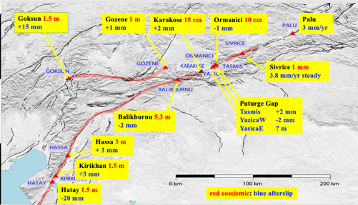

Figure 1 Location of creepmeters on the East Anatolian fault system

kaya, taş içeren bir resim

Açıklama otomatik olarak oluşturuldu

**Figure 1**. Palu creepmeters. Two creepmeters were operated here until tunnel repairs 2021/2 destroyed both sensors. As a result no 2023 coseismic slip was recorded. The north sensor was repaired in March 2023, but the south sensor was returned to Boulder for repair.



**Figure 2** Five years of creep from the north and south walls of the railroad tunnel that crosses the East Anatolian fault beneath Palu Castle. The faster rate from the south sensor arises from its 16-m-measurement-length compared to 8 m for the northern instrument. Neither of the Palu creepmeters were operating at the time of the Kahramanmaras earthquakes due to damage from tunnel engineering activities. The north sensor was repaired in March 2023. Its subsequent temperture corrected rate is similar to that before the February earthquakes (figure 16C).



Figure 3 The Palu creepmeter is exposed to air flowing through the railroad tunnel with a daily variation of about 4°C. Trains act as pistons, propelling outside air through the tunnel at 30-60 km/hr and causing thermoelastic fluctuations in the sensors at ten minute periods. The seasonal effect (a tunnel lining expansion effect at >monthly periods) amounts to 0.25 mm/°C and is superimposed on a diurnal variation of 0.025 mm/°C (a direct effect on the instrument). When the tunnel lining thermal contribution is removed from the creep record the resulting signal indicates < 1mm of slip March-September 2023 (red trace). The smooth data June-Sept results from the suppression of high-frequency noise from a faulty battery pack during this time period which required interpolation to elimate spikes in the record.



Figure 4 Detrended data from north and south sensors