**Srivice**, submergible sensor at 1.5 m depth, 38.3880N, 39.1873E, length 16 m, obliquity 30°

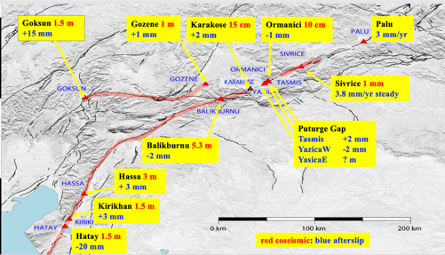

Map showing site locations with coseismic offsets in red, and 2023 pos-seismic slip in blue.

vadi, kanyon içeren bir resim

Açıklama otomatik olarak oluşturuldu

Figure 1. Location of the Sivrice creepmeter. The Sivrice instriument was installed 12 days after the 2020 Mw6.8 Sivrice earthquake and has operated continuously since then, with minor gaps. Crucial data were collected by Mehmet Kokum, most recently two weeks before the earthquakes, and during a subsequent visit in March. Telemetry was installed in June 2023 but was subsequently terminated due to government cell policy. Autonomous recording system overlaps some of this telemetry. Triggered slip and fterslip 2020-23 is shown in Figure 1. A close up of a creep event is shown in Figure 3. All the data are depicted in Figure 5. Since late 2021 the creep rate has approximated 3.8 mm/year.

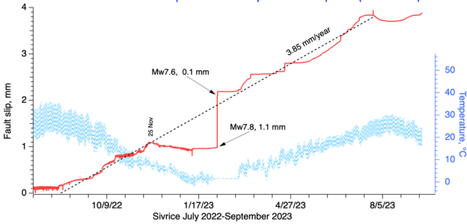

Figure 2 Coseismic and post-seismic displacements at Sivrice to September 2023. The apparent cessation of slip from 25 November to two weeks after the earthquake coincides with a period of frozen ground. Triggered slip induced during the surface waves of the Mw7.8 and 7.6 earthquakes overcame this retardation and slip was resumed when the snow melted as indicated by the time that the temperature record at 0°C rose above zero.



Figure 3 A double creep event 14-17 Sept propagated 45 km from Yasica West to Sivrice in 18.9 hours at 2.3±0.1 km/hr. Minor reductions in rate at Ormanici and Yasica East accompanied the slip events. The amplitudes of events reduced northwards, the first event by a factor of ten, the second only by a factor of two. The events in the creep doublet are separated in time by about 48.7 hours both at start and end. No rain occurred in the month of September



Figure 4 The amplitude of the creep events at Yasica West are small (212 µm and 47.6 µm) but each has a duration of several hours and the time history is consistent with creep events elsewhere. The amplitudes of the creep events at Sivrice are yet smaller (16.9 µm and 26.1 µm) but have similar time histories. The ability for a trivial amplitude double-fault displacement to propagate 45 km with minimal attenuation and effectively no dispersive evolution is considered remarkable and may arise because it represents the surface slip of a significantly larger propagating event in the subsurface. For example, it is possible that the observed signal is not surface slip but the shear strain signature of this deeper process. Maximum strain at Yasica corresponds to 4x10-5, and the minor reductions in rate at Ormanici and Yasica East may correspond to the relaxation of flank strain near the fault due to the passage of this inferred deep-seated dislocation.



Figure 5 indicates cumulative slip to October 2024. Three gaps in the data occur. The first was caused by memory overflow in the data logger. The second was caused by power failure. The third was caused by corrosion of the submerged sensor, which was subsequently replaced with an improved submersible design.