**Tasmis**: 38.2049°N, 38.7872°E, July length 11 m, 27 Sept length increased to 52 m

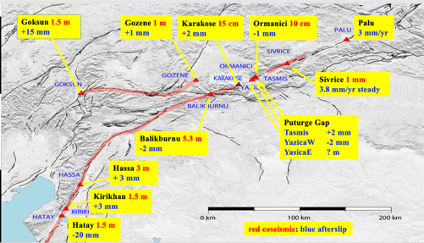

Map showing site locations

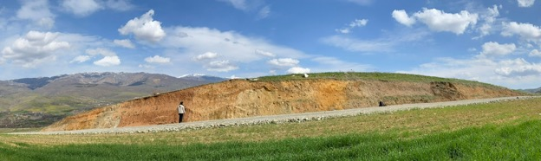

Figure 1 View NE of the Tasmis fault exposure. The creepmeter was initally installed above the road cutting but was subsequently shifted to the foreground region SW of the road.

An 11 m creepmeter was located north and above what appears to be a recent rupture of a 100 m wide gouge zone exposed in a road cutting south of the river. The instrument was installed near the center of the cutting (between the standing figure and a white quartz boulder on the surface. A laminar slip zone is evident in the section (above the yellow shaded NE moving part of the fault, samples from which were submitted to Johanna Nevitt (USGS) for analysis. The surface above the fault appears to have been compressed or extruded as an almost imperceptible NW verging thrust above the figure extending >10 m into the field above the cutting parallel to the fault.

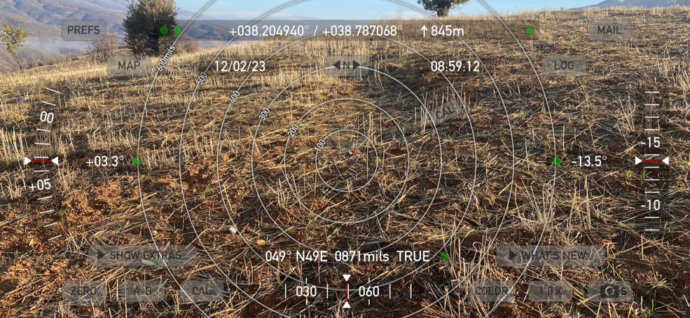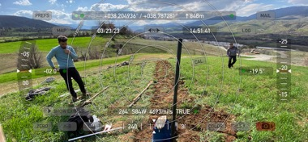Figure 2. Tasmis 11 m creepmeter during installation and close up of the fault section. Three cGPS NetRS receivers were installed in late September to record subsurface slip and three additional sites were installed for future campaign measurements. The surface above the cutting show minor pushups in the clay soil indicative of recent slip.

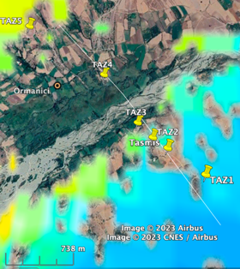

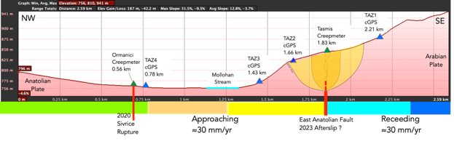

Figure 2 Topographic cross section and map view of cGPS array through the fault near Tasmis. View of 52 m trench prior to burial of creepmeter.

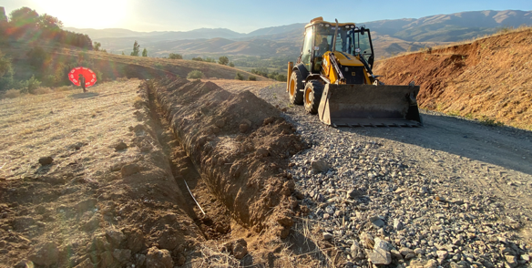

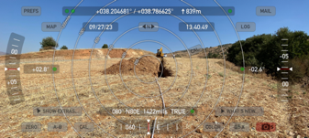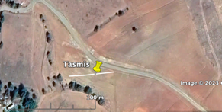

Figure 3. At the end of September the land owner indicated construction of a house on the site of the creepmeter was pending and the Tasmis extensometer was reinstalled to the SW and lengthened to 52 m at a depth of about 1.3 m with azimuth N80E. The fault here strikes ≈N50E. The passive end adjoins the road and the active end (about 2 m lower) is installed near a stream gulley into which two 4 m pipes drain the sensor vault. The slope to the gulley reduces overburden access to the sensor to a depth of ≈50 cm. The current instrument is both transmitted and recorded locally at 1 sample per minute.



**Figure 4** New Tasmis Data. Two weeks of data from the 52 m long creepmeter showing transmitted displacement in mm. A nearby Mw=5.1 aftershock offset the record 24 Oct with no change in rate. The offset occurred between 1 minute samples, suggestion instrument instability (strong motion shaking) but the absence of overshoot (backlash or hysteresis) suggests that the aftershock resulted in incremental strain within the 25 m fault normal aperture of the instrument. If this is the case, the measured signal may be measuring the strain from a dislocation moving steadily at depth. On 16 Sept (four days before this instrument was installed) a creep event propagated northward at ≈2 km/hour between Yasica and Sivrice. (Figure 15).

Since 52 m is almost twice the length of the longest extensometer installed hitherto, its early performance is of interest. The signal increments at the time of diurnal temperature increase suggesting thermal expansion of the ground overcomes friction in the pipe/tensioning system, and that hysteresis is responsible for the plateau between these diurnal increments, masking a contractional cycle of a few microns. It is possible that the instrument currently records strain associated with subsurface slip. Full scale 400 µm in the plot corresponds to ≈2x10-6 strain.



**Figure 5** Hybrid record of Tasmis data. The instrument was initially 11 m long but in late 2023 was extended to 52 m. We consider it probable that the record immediately after installation was contaminated by settlement. Subsequent data were noisy due to a bad voltage regulator board connected to the Iridium transmitter. This was replaced in May 2024 but noisy patches of data continue to occur. Sinistral offets accompany local earthquakes. Least squares fits to the data before and after re-installation suggest a creep rate of 2.6 mm/year.

**Data**

Two data files are provided: the first lists 1-minute sampled local data from the 11 m creepmeter including temperature data in degrees C (Tasmis_2023.txt), the second lists all the data with 1 minute and 10 minute time tags but with no temperature data (Tasmis 2023_25_hybrid.txt)