**Yazica East**: 38.1791°N, 38.7424°E, 30° oblique length=20 m. Interred depth 1-1.5 m

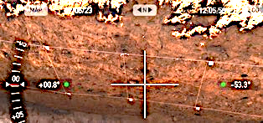The creepmeter was installed in line with a fault trace exposed in a nearby paleoseismic trench excavated by Mehmet Kokum. The passive west end lies about 8 m from this trench and the 20-m-long measurement rod crosses the fault at 30°. The measurement system is a vertical axis submergible sensor E33.47 with a down facing diving bell and protective cover irretrievably buried at a depth of about 1.5 m at its eastern end. A backhoe both dug the trench and filled it and there was no possibility to construct an inspection vault. The data logger has been placed in a down-facing insulated plastic box on the surface directly above the sensor and covered with rocks. The photo faces northeast and is aligned with the creepmeter and its sensor end is marked with a white pipe. 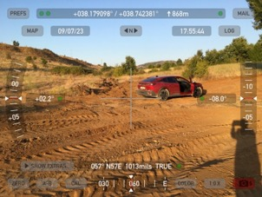

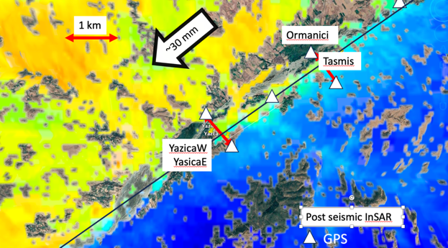

Figure 1 (Top left) View along buried Yazica East creepmeter installed 28 September. (Top right) View east wall of trench with fault covered by ≈50 cm of colluvium (Lower panel) post-seismic Sentinel interferogram (processed by Kang Wang) showing locations of creepmeters and proposed cGPS sites. Black line indicates approximate location of fault. The Tasmis cGPS array was installed in late September.



Figure 2 Data from the Yazica East creepmeter. The large Nov/Dec transient is considered to result from trench consolidation during heavy rain following installation. Although the creepmeter crosses a surface branch of the East Anatolian fault (documented in the nearby trench) no significant creep has occurred.