**Yazica West**: 38.1806°N, 38.7361°E, length=5 m

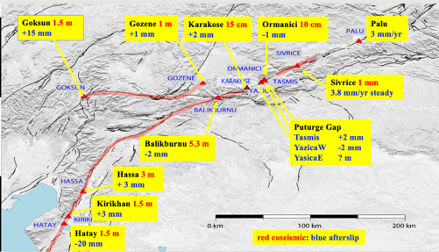

Figure 1 Location of creepmeters on the East Anatolian fault system

doğa, kanyon içeren bir resim

Açıklama otomatik olarak oluşturuldu

Figure 1. The Yazica-west creepmeter was placed across what was interepreted to be a surface rupture following the 2020 Elazig earthquake. Villagers in the adjoing house reported minor cracks appearing across the fault after the 6 February 2023 earthquakes and a creep event was recorded there 16 September 2023 followed by others. The photo shows the NW corner of a house in front of which the 2020 and 2023 cracks passed towards. The white pipe indicates the installation path of the sensor.

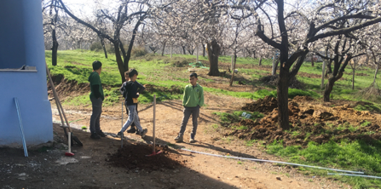

Figure 2 Cracks developed from the bottom left passing in front of the tree after both the 2020 and 2023 earthquakes. The sensor was initially installed where the boy holds a vertical pole but was subsequently shifted to the lower end to the right to permit the owner to drive to the side of his house. Prior to shifting it, the sensor was flooded a couple of times due to water source on the side of the house



Figure 3 Creep event propagation to the NE from Yazica to Sivrice in September 2023.

In June 2023 the passive and active ends were reversed (the sensor and data logger were placed at the downhill end of the creepmeter so that it would not be in the way of the owner of the house). 1.5 mm of contraction occurred between March and September 2023, but a sinistral creep event was recorded here 14 Sept. The instrument operates from batteries.



Figure 4. Yazika_West creep data 2023 2024 show net contraction which may represent downhill creep of the foundations of the nearby house. Occasional sinistral creep events confirm that it crosses a surface branch of the East Anatolian fault, however, these are infrequent. Due to the location of the instrument next to the house, and to the possibility of tractors driving close-to or over the ends of the creepmeter, the data incude noise of uncertain origin related to activities of people and vehicles. No reliable long term creep-rate data can be obtained from this location.

 